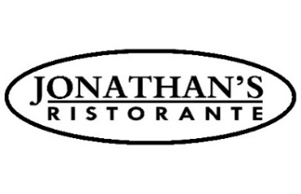
DINNER MENU

SALADS

Insalata Amalfitana
white anchovies, watermelon radish,
arugula, onion, fennel & cucumber 17

Classic Ceasar Salad *
shaved parmigiano
& homemade croutons 16

APPETIZERS

Arancini
mushroom mini rice balls with truffle aioli 14

Fritto di Carciofini
sautéed baby artichokes
& basil pesto 16

Prosciutto di Parma
mozzarella di bufala
& fresh figs 23

Polpo
vignarola salad: pancetta,
artichoke, fava, peas 22

Burrata
cashews, walnuts, pistachio, granola & fig balsamic 20

Tuna Tartare *
raw yellow-fin tuna, avocado salad, cucumber
& wasabi mayo 24

PASTA

Bucatini All’Amatriciana
pancetta, onion & tomato sauce 27

Spaghetti Bolognese
nonna alba’s bolognese sauce 28

Linguine Nere con Gamberi
black linguine spicy san marzano
tomato sauce & tiger shrimp 29

FISH & MEAT

Polletto
free-range bell & evans chicken on the bone
roasted potatoes, lemon/rosemary sauce & french string beans 29

Salmone Scozzese *
butternut squash, cardoncello mushrooms, apples, walnuts,
haricot vert & apple infused balsamic reduction 36

Branzino
celery root cream, baby spinach, pickled shallots & root chips 35

Maiale con Vegetali Tartufati *
double cut pork chop, cipollini onions, tuscan potatoes, artichokes & truffle oil 42

16 oz. Grass-Fed New York Strip Steak *
peppercorn sauce | truffle butter | salsa verde & herbed fries 54

TONIGHT’S SPECIALS

Steak Tartare
quail egg & crostini 21

Seared Sea Scallops
sauteed baby artichokes, haricot vert & basil pesto app 22 | main 38

Spaghetti
bay scallops, leeks, fresh tomatoes & corn 34

Risotto con Funghi
wild mushroom risotto with seared duck breast 36

Lamb Shank Osso Buco
saffron risotto & asparagus 46

DESSERT SPECIAL

Vanilla Crème Brûlée
with mixed fresh berries 14

*This menu item can be cooked to order. Consuming raw or undercooked meats, fish, shellfish, or fresh shell eggs may increase your risk of food-borne illness, especially if you have certain medical conditions.

